Grass Hay for Horses
Kentucky bluegrass, orchard grass and timothy are all examples of common grasses used for hay.
• Benefits: Grass hay is lower in protein and energy than legume hay — but it’s also higher in fiber, which can make it a good choice for many horses. Since it’s less nutrient-dense than legume hay, horses have to eat more grass hay to fill their bellies, which makes grass hay a good tool for keeping a stall-bound horse from getting bored.
• Downsides: Grass hay alone may not be enough to sustain a hard-keeping horse, a growing horse or a pregnant or lactating mare. Additionally, horses in heavy work will need more energy and nutrients than can be found in grass hay alone.
• Best for: Easy keepers, horses in light work (or retired horses), and as a tool to help buffer stomach acid and add roughage without adding too many calories or excess protein. Providing nutrient-light, bulky grass hay can closely mimic the horse’s natural pattern of grazing slowly and processing fibrous feed equally slowly and steadily through the digestive system.

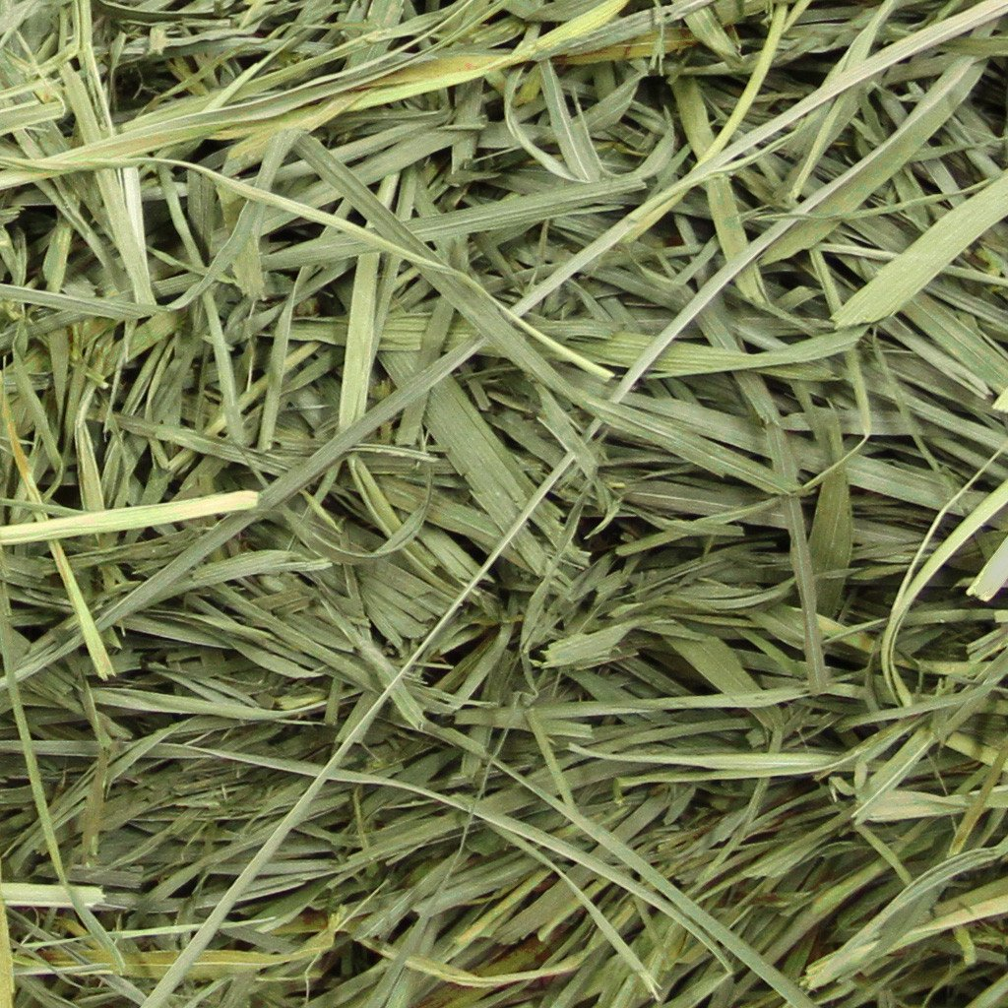
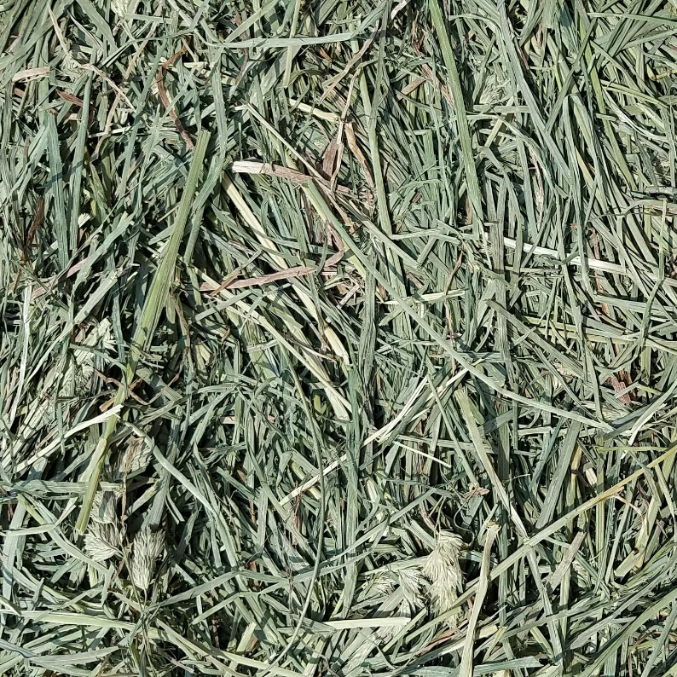
Kentucky Bluegrass Orchard Grass

